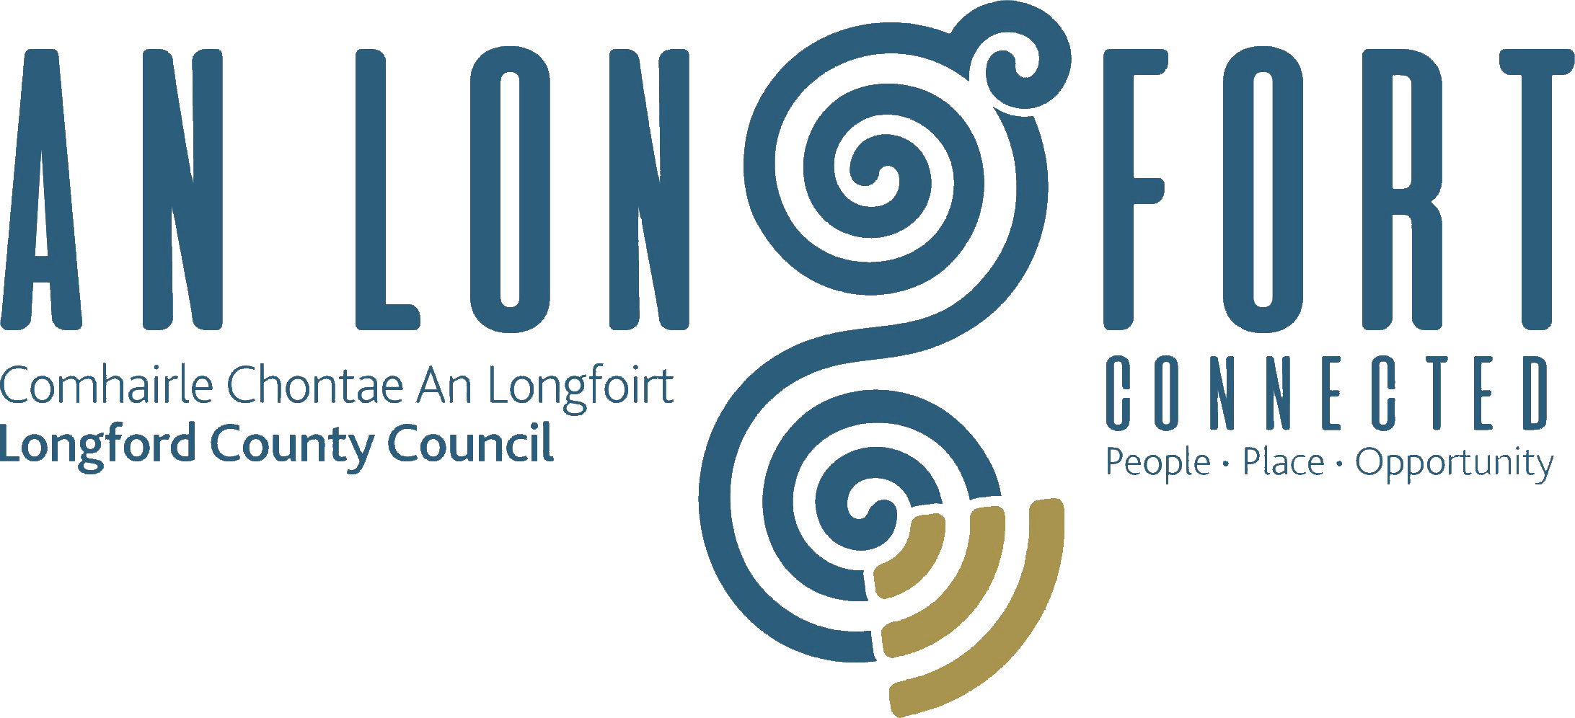

BALLYMAHON MUNICIPAL DISTRICT

Minutes of 2019 Annual Meeting of Ballymahon Municipal District held in the Council Chamber, Aras an Chontae, Longford on Monday, 17th June 2019 at 6.00 p.m.

CATHAOIRLEACH: Councillor Pat O’Toole

MEMBERS PRESENT: Councillors – Mick Cahill, Mark Casey, Colm Murray,
Gerard Farrell and Paul Ross.

IN ATTENDANCE: Mr. Paddy Mahon, Chief Executive.
Ms. Barbara Heslin, Director of Services.
Mr. Paul Newell, Senior Executive Engineer.
Mr. John McKeon, Head of Finance.

MEETINGS
ADMINISTRATOR: Ms. Anne. Lee.

ELECTION OF CATHAOIRLEACH.

It was proposed by Councillor M. Cahill and seconded by Councillor P. Ross that
Councillor Pat O’Toole be elected Cathaoirleach of Ballymahon Municipal District
As there was no other nomination, Councillor O’Toole was, thereby, elected Cathaoirleach of Ballymahon Municipal District until the Annual Meeting in 2020.

The Chain of Office was formally conferred on Councillor O’Toole by the Chief Executive.

VOTE OF SYMPATHY.

The meeting adjourned for five minutes as a mark of respect to Councillor Mick Cahill on the death of his mother, Eileen.

ELECTION OF LEAS CATHAOIRLEACH:

It was proposed by Councillor G. Farrell and seconded by Councillor M. Cahill that Councillor Colm Murray be elected Leas Cathaoirleach.

As there was no other nomination, Councillor Murray was, thereby, elected
Leas Cathaoirleach of Ballymahon Municipal District until the Annual Meeting in 2020.

Councillor O’Toole thanked his proposer and seconder and the Members for electing him as Cathaoirleach of the Municipal District for the coming twelve months and congratulated Councillor Murray on being elected Leas Cathaoirleach.

He stated that he will work ardently for the Municipal District during his term as Cathaoirleach and outlined his priorities for the year ahead.

All the Members joined in wishing Councillor O’Toole every success during his term of office as Cathaoirleach and also congratulated Councillor Murray.

Councillor Murray thanked his proposer and seconder and congratulated Councillor O’Toole on being elected Cathaoirleach.

The Chief Executive on his own behalf and on behalf of the staff of the Council joined with the elected Members in congratulating Councillors O’Toole and Murray.

He wished Councillor O’Toole well in the year ahead and offered him the full support and that of all the staff during his term of office.

Barbara Heslin congratulated Councillor O’Toole and Councillor Murray and said she looked forward to working with the Ballymahon Elected members in what is going to be an exciting time for the Municipal District.

APPOINTMENT OF ONE MEMBER TO LONGFORD ENTERPRISE DEVELOPMENT COMPANY LTD:

Councillor C. Murray proposed and Councillor P. Ross seconded that
Councillor Mick Cahill be appointed to Longford Enterprise Development Company Ltd.

The Cathaoirleach declared Councillor Cahill appointed a member of Longford Enterprise Development Company Ltd.

APPOINTMENT OF THREE MEMBERS FROM EACH MUNICIPAL DISTRICT TO THE REGENERATION COMMITTEE.

Councillor C. Murray proposed and Councillor G. Farrell seconded that
Councillors Gerard Farrell, Paul Ross and Mick Cahill be appointed to the Regeneration Committee.

The Cathaoirleach declared Councillor Gerard Farrell, Councillor Paul Ross and Councillor Mick Cahill appointed members of the Regeneration Committee

APPOINTMENT OF ONE MEMBER FROM EACH MUNICIPAL DSITRICT TO THE CREATIVE IRELAND CULTURE TEAM.

Councillor C. Murray proposed and Councillor M. Cahill seconded that
Councillor Pat O’Toole be appointed to The Creative Ireland Culture Team.

The Cathaoirleach declared Councillor Pat O’Toole appointed a member of
The Creative Ireland Culture Team

APPOINTMENT OF ONE MEMBER TO THE COUNTY LONGFORD HERITAGE FORUM.

Councillor C. Murray proposed and Councillor M. Cahill seconded that
Councillor Paul Ross be appointed to The County Longford Heritage Forum.

The Cathaoirleach declared Councillor Paul Ross appointed to The County Longford Heritage Forum.

APPOINTMENT OF ONE MEMBER FROM EACH MUNICIPAL DISTRICT TO COUNTY LONGFORD TOURISM COMMITTEE.

Councillor C. Murray proposed and Councillor M. Cahill seconded that
Councillor Gerard Farrell be appointed to County Longford Tourism Committee.

The Cathaoirleach declared Councillor Gerard Farrell appointed to County Longford Tourism Committee

ARRANGEMENTS FOR BALLYMAHON MUNICIPAL DISTRICT MEETINGS.

It was agreed that Ballymahon Municipal District Meetings be held on the fourth Thursday of every second month commencing at 4.00 p.m. in Ballymahon Community Library.

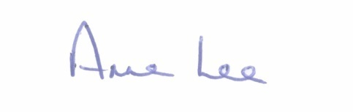
This concluded the business of the meeting.

Signed: _______________
Anne Lee,
Meetings Administrator.

Confirmed and adopted at Ballymahon Municipal District Meeting held on the
25th July 2019.

Signed: _______________
Cathaoirleach.

